**NthFibonacci | NthFibonacci.java**

Given a number n, print n-th Fibonacci Number.

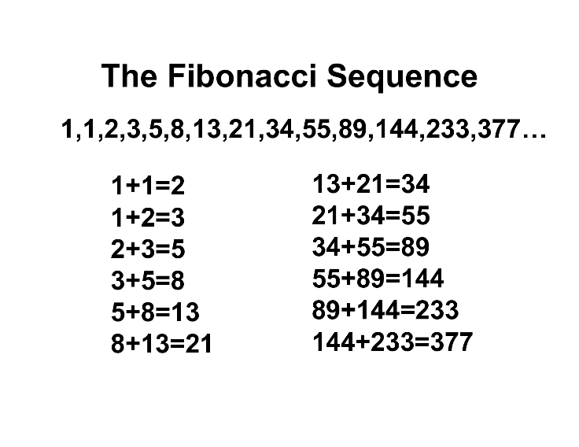

**Test 1**

Enter the number n

10

The 10th Fibonacci number is: 55

**Test 2**

Enter the number n

6

The 6th Fibonacci number is: 8

**Test 3**

Enter the number n

14

The 14th Fibonacci number is: 377